**Lexar® JumpDrive® Fingerprint F35 PRO USB 3.2 Gen 1 Flash Drive**

256GB

[Where to buy](https://americas.lexar.com/product/lexar-jumpdrive-fingerprint-f35-pro-flash-drive/)

**Key Features:**

Up to 400MB/s read, 350MB/s write speeds

* Fingerprint authentication2 provides an extra layer of security for confidential files
* Save up to 10 different fingerprints
* Ultra-fast recognition – less than 1 second
* 256-bit AES encryption also protects your files
* Striking design with durable metal body

[Features](https://americas.lexar.com/product/lexar-jumpdrive-fingerprint-f35-pro-flash-drive/#feature-section)[Specifications](https://americas.lexar.com/product/lexar-jumpdrive-fingerprint-f35-pro-flash-drive/#specifications)[Part Numbers](https://americas.lexar.com/product/lexar-jumpdrive-fingerprint-f35-pro-flash-drive/#product-numbers)[Related products](https://americas.lexar.com/product/lexar-jumpdrive-fingerprint-f35-pro-flash-drive/#related-products)

**Features**

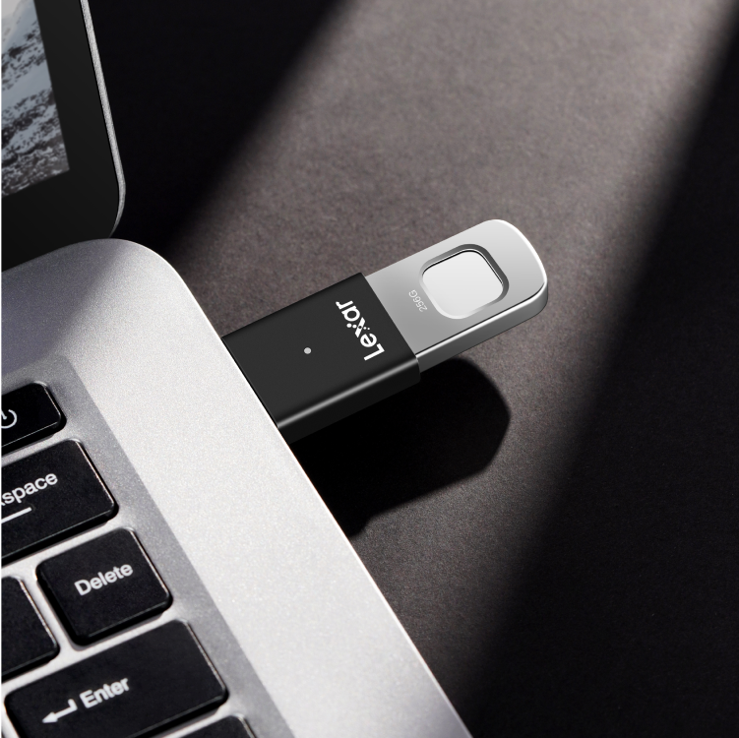

**Extra security for confidential files**

The Lexar JumpDrive Fingerprint F35 Pro USB drive takes security to the next level. Access files on the drive with fingerprint authentication. With up to ten different fingerprint IDs, all of your closest collaborators will have easy, secure access to the files they need. Plus, with up to 400MB/s read and 350MB/s write speeds, you’ll have the performance you need to quickly transfer files when needed.

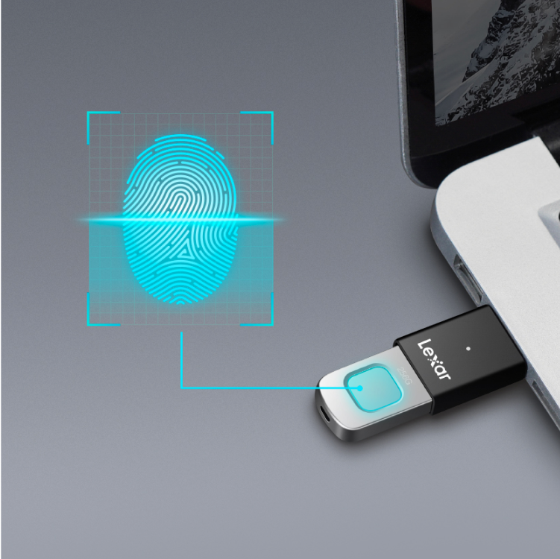

**Access files with the touch of a finger**

The Lexar JumpDrive Fingerprint F35 Pro USB drive uses your fingerprint to authenticate access to your files. No passwords or codes to remember.

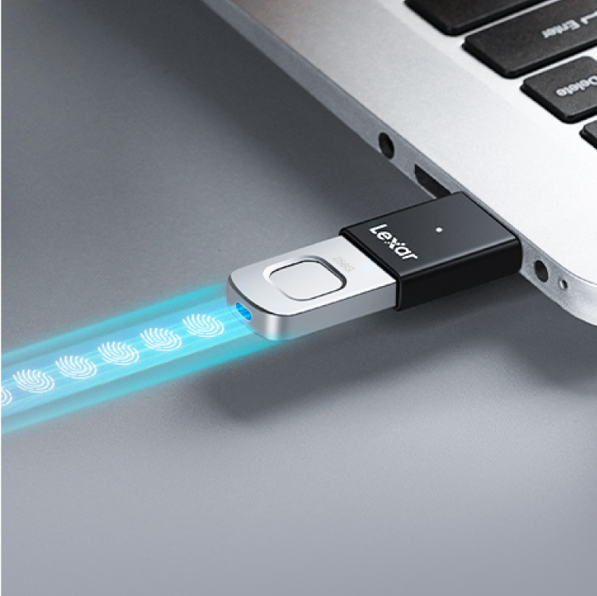

**Save up to ten fingerprint IDs**

You can save up to ten different fingerprints2 to your drive. So you can add your family, partners, or business collaborators.

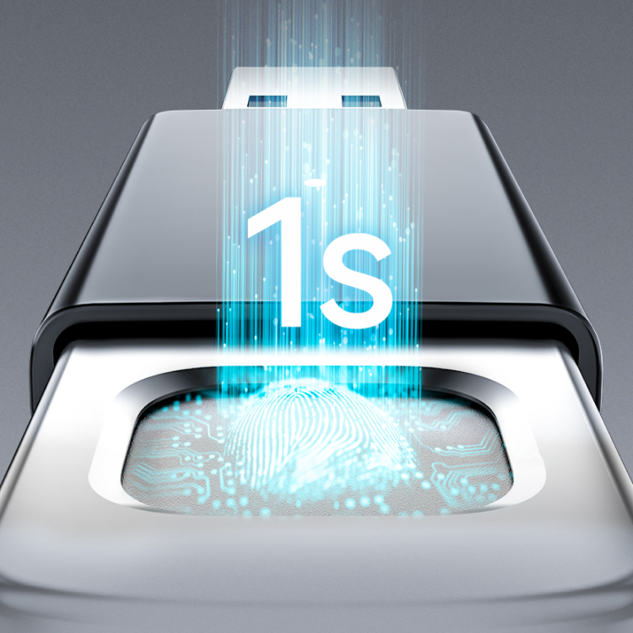

**Ultra-fast access**

The Lexar JumpDrive® Fingerprint F35 Pro USB drive’s technology recognizes your fingerprint ID in less than 1 second, giving you almost instant access.

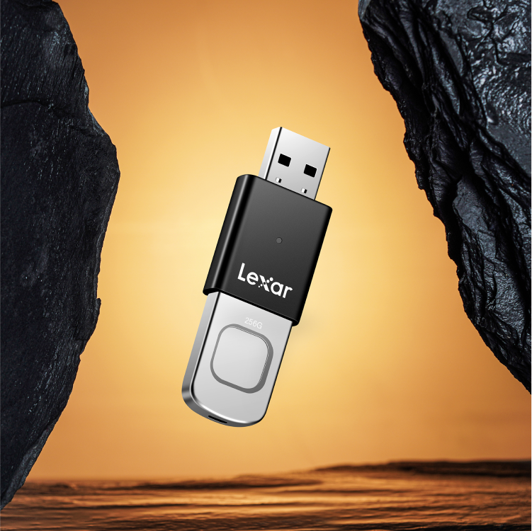

**Striking, durable design**

A stylish metal design and a protective slider help protect your data by keeping the connector and contents safe.



**Rigorously Tested**

As if the use of your fingerprint to access your drive wasn’t already secure enough, this drive comes with 256-bit AES encryption to protect your critical files.

**Specifications**

* Capacity

256GB

* Interface

USB 3.2 Gen 1

* Performance

400MB/s read, 350MB/s write1

* Operating Temperature

0°to 50°C (32°F to 122°F)

* Storage Temperature

-10°to 70°C (14°F to 158°F)

* Dimension (L x W x H)

20.4 x 61.57 x 7. 9mm (0.803” x 2.424” x 0. 311”)

* Weight

16g / .035lbs

* System Supported

Mac®, Windows XP®, Windows® Vista, Windows 7, 8, 10, Linux2. NOTE: Fingerprint registration software required to create/edit accounts and adjust partition size.

* Warranty

3-year limited warranty

* Function

Fingerprint technology